1. Login to <https://emea-de-090.asn.saacon.net/Citrix/SaaconV4/site/default.aspx>

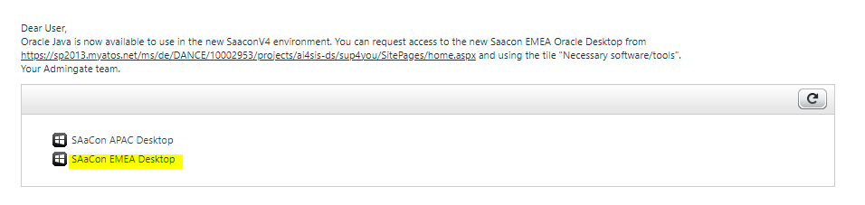

1. Login to ATA jumphost- 156.150.45.154

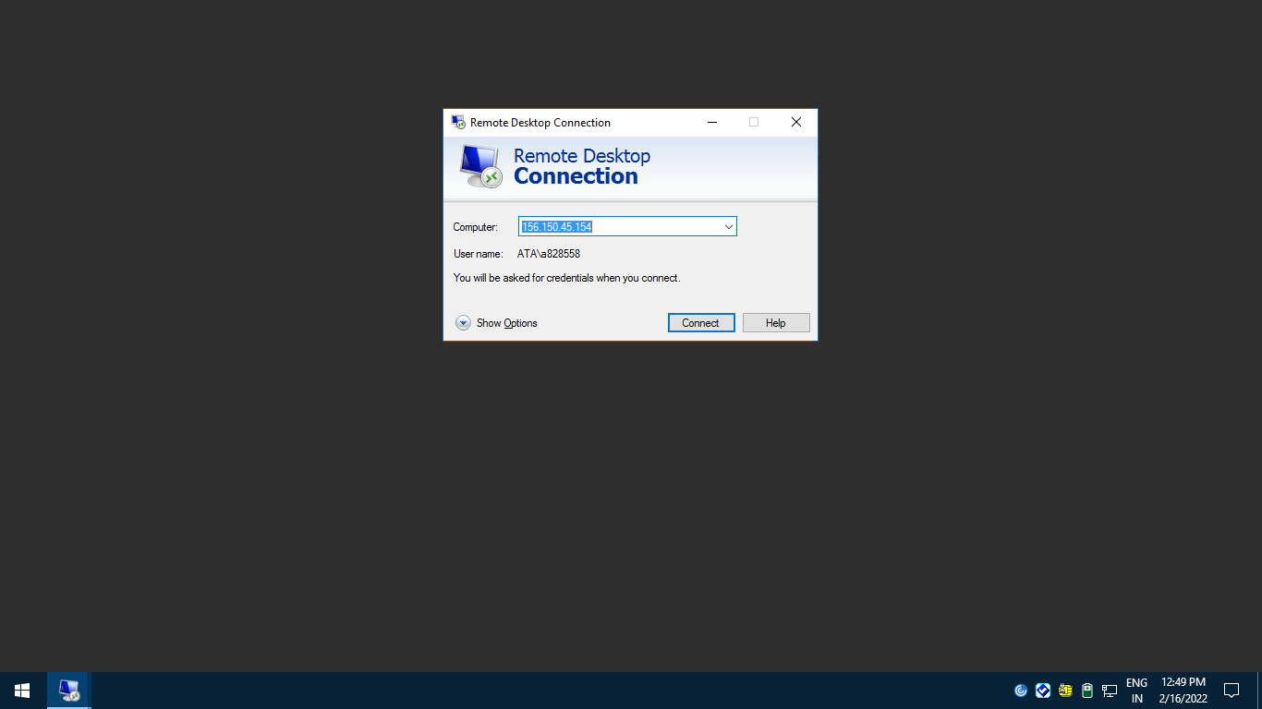

1. Login to atapmgtpadc0001 computer using ATA account

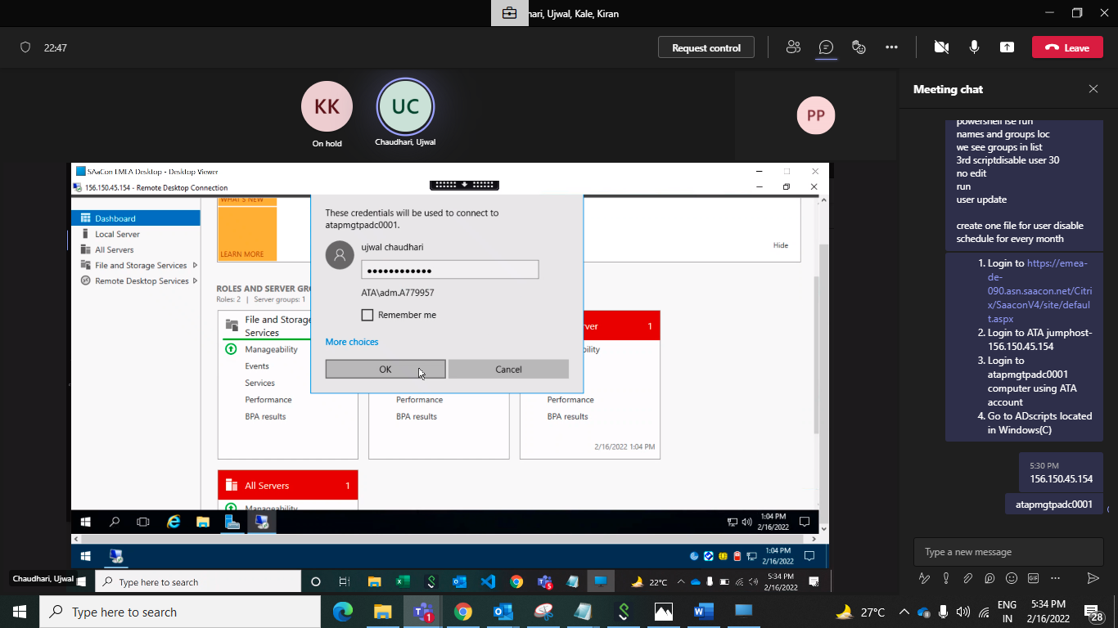

1. Go to ADscripts located in Windows(C)

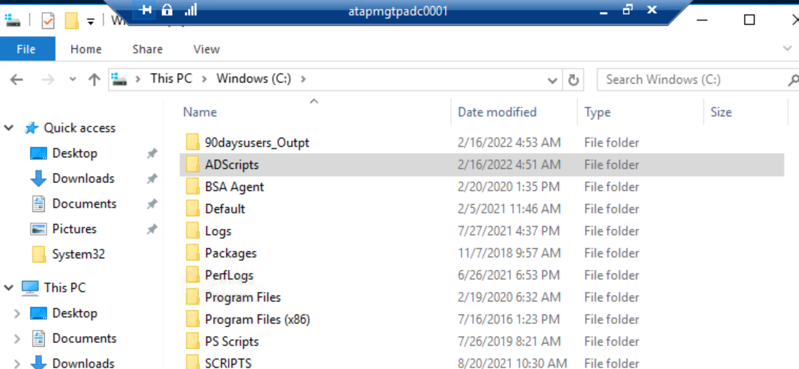

1. Run PasswordExpireUser-30Days script with the help of Windows Powershell ISE

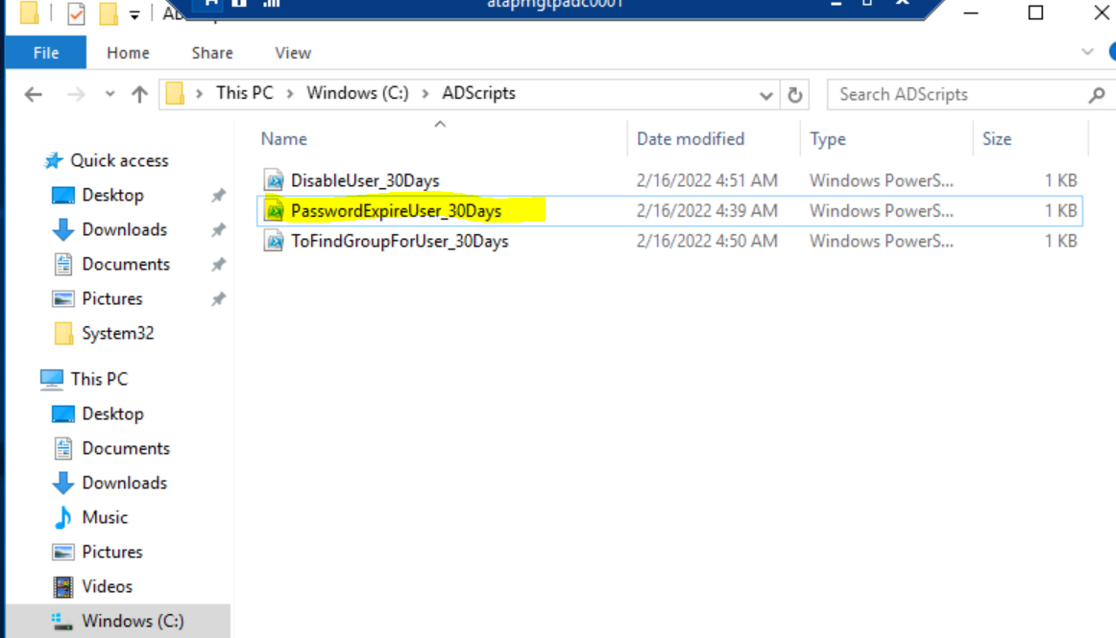

1. Change the month name in script for which we are checking account access

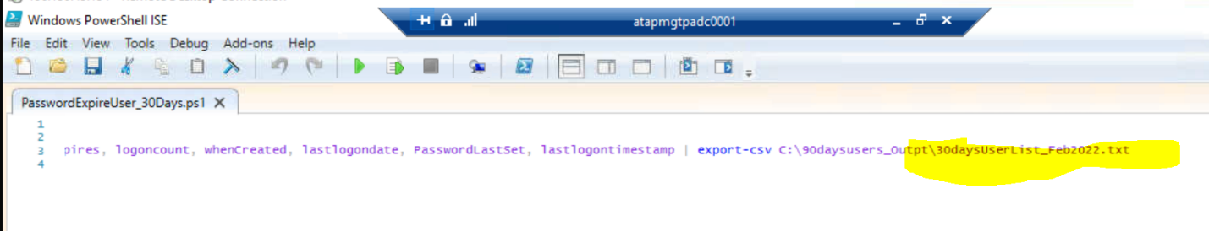

1. After running the script go into 90daysusers-Outpt located in C drive and open 30daysUserList for particular month.

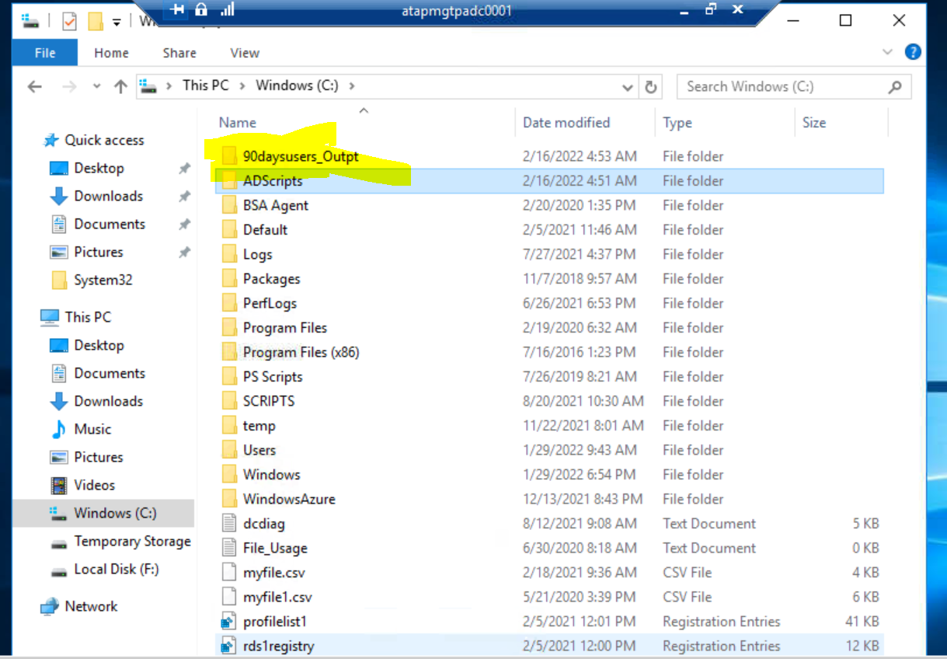

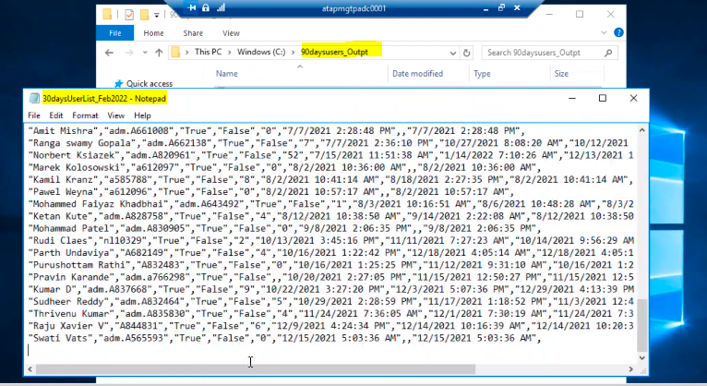

1. Sort the text document into your local computer excel and mail users if account is required or not. Update the sheet on sharepoint as well

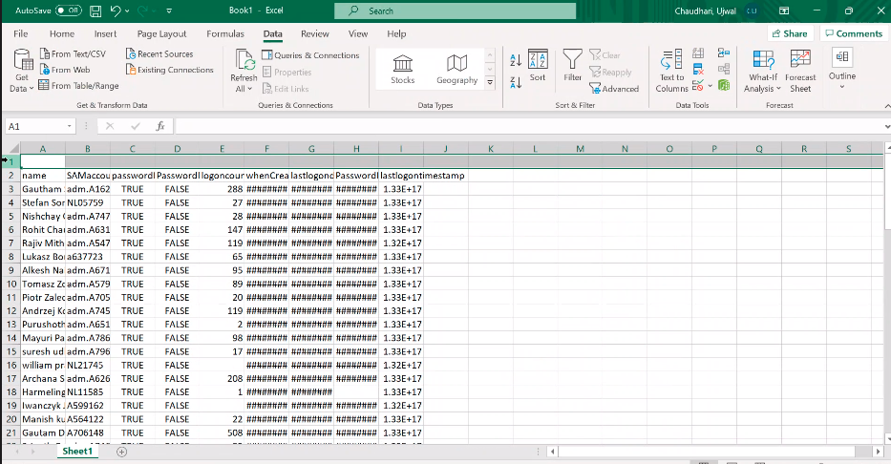

1. Run the second script ToFindGroupForUser-30days in Windows powershell ISE to check the group of user

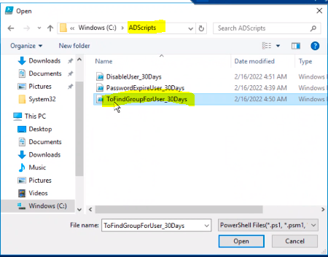

1. Change the month name in script for which we are checking account access

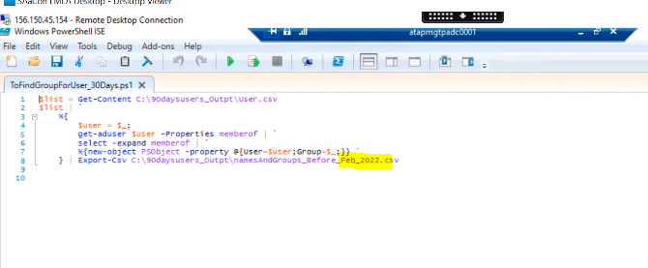

1. Open the output file namesAndGroups-Before for script ToFindGroupForUser-30days which is located in 90daysusersOutpt>Adscript>C Drive

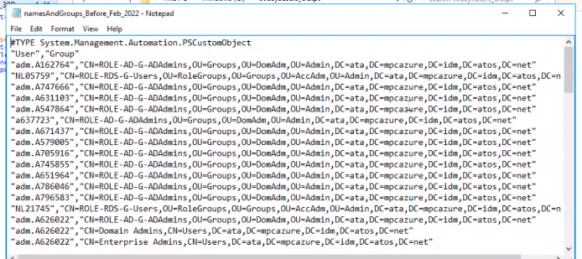

1. Sort the text document into you local computer excel and check for Groups ie service accounts and user accounts

If service accounts are present then we need to exclude them. Service account is showed up as SVC-

For user accounts send mail to specific user and get a confirmation if account access is required or not.

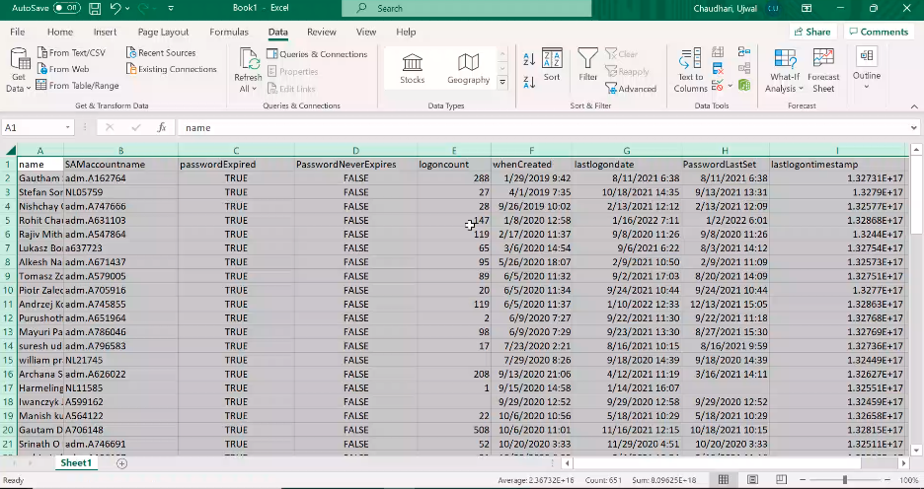

1. Save the data for which we got confirmation to disable access into User.csv file
2. Third script which is located in Adscript>C drive will disable the users after running through Windows powershell ISE.

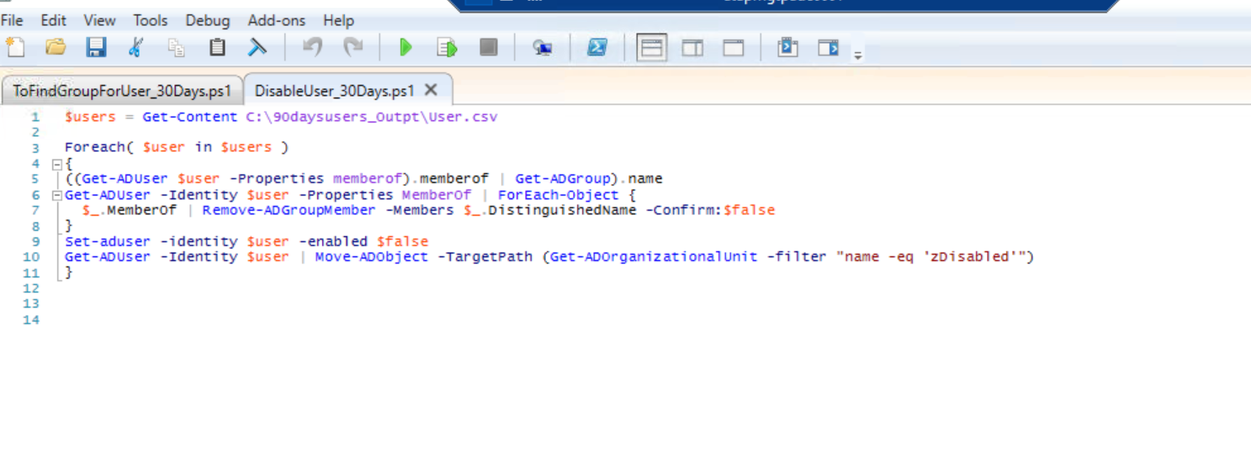

1. All the disable accounts can be seen in User.csv